Intentions

Sat 03 5:00 pm Sam & Rita Utrup,
50th Anniversary
Sun 04 7:30 am For Souls in Purgatory 9:30 am Dick German
Alan Schroeder
Mon 05 7:00 pm Prayer Service
Tues 06 7:00 pm Dorothy Warnecke
Wed 07 8:00 am For Those with Cancer
Thurs 08 7:00 pm Gerald Saum
Fri 09 7:55 am Tom Warnement
Sat 10 5:00 pm Class of 1979
Sun 11 7:30 am For Souls in Purgatory
9:30 am Dick & Irma Warnecke

THIS WEEK’S READINGS
Mon 08/05 Dedication of the Basilica
Of Saint Mary Major
Nm 11:4b-15 Mt 14:13-21
2Pt 1:16-19
Tues 08/06 The Transfiguration of the Lord
Dn 7:9-10, 13-14 2Pt 4:16-19
Wed 08/07 Saint Sixtus II, Pope and Companions,
Martyrs; Saint Cajetan, Priest
Nm 13:1-2, 25 14:1, 26-29a, 34-35
Mt 15:21-28
Thu 08/08 Saint Dominic, Priest
Nm 20:1-13 Mt 16:13-23
Fri 08/09 Saint Teresa Benedicta of the Cross,
Virgin and Martyr
Dt 4:32-40 Mt 16:24-28
Sat 08/03 Saint Lawrence, Deacon
2Cor 9:6-10 Jn 12:24-26

RCIA will begin on Sunday, September 1st from immediately following 9:30 Mass until 11:45. The RCIA is for those discerning a call to enter the Catholic Church as well as for Catholics who, for whatever reason, have not yet received their First Communion and/or Confirmation. If you are interested in joining RCIA, please contact Karan Maenle at 419-286-2877.

Have you ever wondered what the Catholic Church really teaches about the Bible, Mary, the Communion of Saints, Eucharist, Baptism, Marriage, Papal Authority, Confession, Purgatory, the End times, etc.? If so, this inquiry class, known as RCIA (Rite of Christian Initiation for Adults) may be just what you’ve been looking for!

WEEKDAY SERVERS

Tuesday, Aug. 6, Thursday, Aug. 8, Friday, Aug. 9
Ian Howbert, Brandt Menke, Maggie Pothast

LITURGICAL MINISTERS - August 10 & 11:
SERVERS:
5:00pm Noah Wittler, Rayle Clay,
Tyler Kahle
7:30 am Elizabeth Howbert, Eric Wieging,
Anna Wisner
9:30 am Grace Fischbach, Reilly Fitzpatrick,
Brooke Hellman
OFFERTORY GIFTS:
5:00 pm Class of 1979
7:30 am Volunteers Needed
9:30 am Warnecke Family
EUCHARISTIC MINISTERS:
5:00 pm Don Bonifas, Amy Eickholt, Deena Walsh, Sharon Kleman, Doreen Knippen,
Hannah Knippen
7:30 am Volunteers Needed
9:30 am Theresa Wurst, Nicole Wrasman, Anita Aldrich, Gilbert Burgei, Matt Dube,
Deb Dulle
LECTORS:
5:00 pm John Michel
7:30 am Volunteers Needed
9:30 am Cheryl Hellman
USHERS:
5:00 pm Rick Maag, Dan Krietemeyer
7:30 am Volunteers Needed
9:30 am Pat & Tom Liebrecht

Please Pray for the Sick:

Penney Gerdeman, Tom Grubenhoff, Tracey Lucke

July 28, 2019
Envelopes $ 2861.00
Loose $ 556.00
Maintenance $ 0.00

YTD as of July 28, 2019 = $ 12,595.25
YTD Under Budget = $ - 3,404.75

Thank you for your generosity and keeping
St. Joseph Parish going strong.

sxdc

Religious Ed Registrations were mailed, if you did not receive one, contact Rhonda at 419-796-9044.

81st Annual St. Joseph Homecoming Festival

It’s time to plan your dessert donation. Pie pans are in the Bride’s Room off the Narthex. Thank you in advance for helping to make our Festival meals the delicious experience they are. For info call Sharon Kleman at 419-302-3596.

THE COUNTRY STORE is asking for donations to raffle off at our Annual Parish Festival again this year. Please take your items with your name on it to the church basement and place it in the room designated for the Country Store or call Kari German (419-235-2353) if you need an item picked up. Thank You!

CHAIRPERSON NEEDED for the Country Store next year. Any interested person(s) will have the ability to shadow our current chairperson this year to see how it is done. If you are interested in taking over the Country Store, contact Kari German at 419-235-2353. This is a very important part of our festival, please consider volunteering for this position.

We are looking for 6 students and 4 adults to help wash roasters at the Legion during the festival. There are two - 2 hour shifts 12-2 and 5-7. This is a great way to get Confirmation hours. Call Michelle Weyrauch 419-604-0413.

FESTIVAL KIDS GAMES in need of volunteers. Adults & older kids welcome. This is a great way for those with limited mobility to help out our Parish! Shifts are 2 hours each. To volunteer contact Jackie (Wehri) Kohls at 567-242-8335. Donations of Water/Gatorade/Juice Boxes/Hugs, Candy & small bags of chips are appreciated. For donation pick up contact Jackie or Trish Moening at 419-796-9645. Thank You!!

The Farmers Market is again asking for donations of homemade baked goods, canned goods, produce, homemade crafts, plant “starts”, etc. for the stand at the Parish Festival. Items can be put in the room marked “Country Store” in the church basement (mark as Farmers Market) or dropped off the day of the festival at the stand. Any questions, please contact Marianne Von Sossan at 419-302-6693.
BAPTISMS: To arrange a baptism please
Call the Parish Office or Deacon Larry (cell)
(419) 302-2532 or by email larry@fjsb.com.

BAPTISM CLASSES
Baptismal Class will be Tuesday, September 10th.
Please attend instructions before
the birth of the child.
**Call the Parish Office to register for class**

Attend a Pre-Marriage Preparation Class
before your marriage.
Find Marriage Prep Classes at
http://ToledoMarriagePrep.org

Bulletin submissions deadline:
Wednesdays at Noon.

Fort Fest is in need of Student Volunteers (grades 5-9) to work the Children's Inflatables area on Friday, August 16th and Saturday, August 17th. Shifts are 2 hours, to supervise the bounce houses & help the little kids as needed. Use for Confirmation Hours. Contact Angie Gasser, 419-302-1166.

Jennings Local Schools has a custodial position opening: Full-Time, preferred hours are 9:30 am - 6:00 pm. Starting wage is $11.80 per hour. Classified Application is available online at https://www.jenningslocal.org/home/district-links/employment. For details please contact Nick Langhals, 419-286-2238 ext. 1001 or n_langhals@jenningslocal.org

St. Anthony of Padua Annual Parish Festival, Columbus Grove ~ Saturday, August 3rd & Sunday, August 4th. Saturday BBQ chicken/spare rib dinners will be available at 5:00 p.m. chicken/beef dinners from 11:00 a.m.-1:30 p.m. Carry outs are available 11:00 a.m.-3:00 p.m. Drive thru carry out until 1:00 p.m. Cafeteria will be open from 4-7 p.m. There are also cash prizes totally $2,500, a Lottery Tree, 3 $100 Gas Cards Drawing and the Chance to win $20,000 towards a new car or $15,000 in cash.

Sons of the American Legion Steak Dinner will be held on Friday, August 16th from 4:30-6:30pm at the Legion Hall. Cost is $12.00 (Includes 8oz Sirloin, Baked Potato, Green Bean Casserole & Garlic Toast.

GOLF CART RAFFLE - $20 per ticket, contact Stacy Warnecke 419-302-7870 or any freedom square member. Tickets also available at Reflections Hair Salon. Proceeds Freedom Square Project. Check out details at Freedom Square Facebook Page. Maximum 1,200 total tickets will be sold.

American Legion Kitchen will be closed on Sunday, August 11th for Homecoming food preparations. Please come and support our Annual Homecoming.

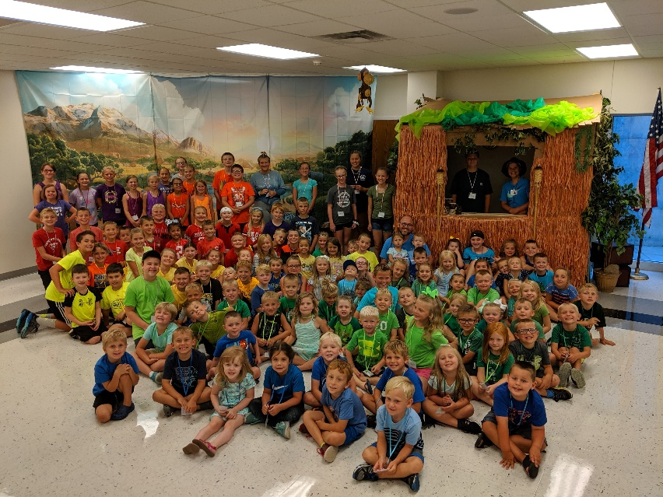
VBS 2019 Group Picture
A Great Big Thank You to everyone who helped make this Vacation Bible School a great success. All the children who attended had a great time. It takes a lot of people a tremendous amount of time to put this together every year and we all appreciate it.

Where did the Summer go??? Time for another school year. Fort Jennings High School will be having orientation for incoming sixth graders and parents on Thursday, August 8th at 9:00am in the Auditeria.

Students in grades 7-12 may pick up their schedules on August 8th between the hours of 1-3pm in the Guidance Office.

First day of school for the 2019/2020 school year will be Monday, August 19th.

A pastor had been invited for supper at a farmer’s home. They had just finished an excellent chicken dinner when the minister saw a rooster strutting through the yard. “That’s certainly a proud-looking rooster,” the pastor commented. “Yes, sir,” replied the farmer. “He has every reason to be proud! One of his sons just entered the ministry!”

American Legion Extended Hours during Fort Fest
Weekend. Friday and Saturday Hours will be 6am-1pm for Breakfast and Lunch.

A preacher whose members consisted mostly of rural farmers decided to preach a sermon he was sure that everyone would understand. Here are the notes:
A Garden Blessed by God
Plant three rows of peas:
- “Peas” of heart
- “Peas” of soul
- “Peas” of mind
Plant three rows of squash:
- Squash gossip
- Squash grumbling
- Squash selfishness
Plant four rows of lettuce:
- Lettuce love one another
- Lettuce be charitable
- Lettuce be faithful
- Lettuce not be discouraged
Plant three rows of turnips:
- Turnip for church each week
- Turnip to serve in a ministry
- Turnip to help one another
Plant six rows of thyme:
- Thyme for the Lord
- Thyme for your family
- Thyme for Prayer
- Thyme for work
- Thyme for rest
- Thyme for play
Water with patience and cultivate with love. You always reap what you sow.

CLC Members – Our local council is hosting a meeting/fun evening with all Putnam County councils on Wednesday, September 11th. It will begin at 6pm at Fort Haven and include a meal, fun, fellowship and games. We are looking for some door prizes and would love to have them donated by our members. If you are willing to donate something, please call, text or email Sharon at 419-306-0367 sharoncalvelage@yahoo.com If you can help that evening please let Sharon know.

The annual meeting of the CLC’s is quickly approaching. It will be on Saturday, October 12th at the Marathon Center for the Performing Arts in Findlay. It is a one-day event starting at 9am until 4pm. All members are invited and if you would like to go, our council will pay the $15 registration fee. Please contact Sharon to make your reservations or for any other information you may need. Reservations are due by September 12th. Just to refresh your minds, there are no longer conventions. They have been replaced with the annual meeting.

